NCL ICS Joint Capital Resource Use Plan 2025/26
Date of publication

Region | London
ICB or system | North Central London
Date published | 15/09/2025

With thanks colleagues in the ICB and Trusts.

Table of contents

Table of contents 2
Introduction 3
System overview 3
Context 3
Ambition and aims 5
Key strategic capital schemes 6
Providers 6
ICB 7
Capital and Estates governance 8
Capital 8
Estates 8
2025/26 CDEL allocations and sources of funding 10
CDEL funding allocation 10
Capital risks 11
Capital prioritisation 13
Setting operational and strategic allocations 13
Operational capital 13
Strategic capital 14
Prioritising national schemes 15
Capital planning 16
Planned spend 16
Backlog maintenance and Critical Infrastructure Risk 17
Overview of ongoing schemes and NHSE business cases in 2025/26 18
Cross-system and collaborative working 22
Local Authorities 22
Other partners 23
Net zero carbon strategy 24
ICB strategy 24
How the capital plan supports net zero 25
Appendix A: System CDEL table 26

Introduction

System overview

Context

North Central London Integrated Care System (NCL ICS)

The North Central London Integrated Care System is a partnership of organisations that delivers health and care services across our five boroughs: Barnet, Camden, Enfield, Haringey and Islington. It is made up of the NHS, local councils, and voluntary sector organisations, working together to improve the lives of residents in North Central London.

One of the 42 ICSs covering all of England, the NCL ICS was legally established on 1 July 2022 to:
- Improve outcomes in population health and healthcare
- Tackle inequalities in outcomes, experience and access
- Enhance productivity and value for money
- Help the NHS support broader local social and economic development

As well as five local councils and 8 NHS Trusts, North Central London includes approximately 180 GP surgeries, 300 pharmacies, 200 care homes and many voluntary, community and social enterprise services providing essential care.

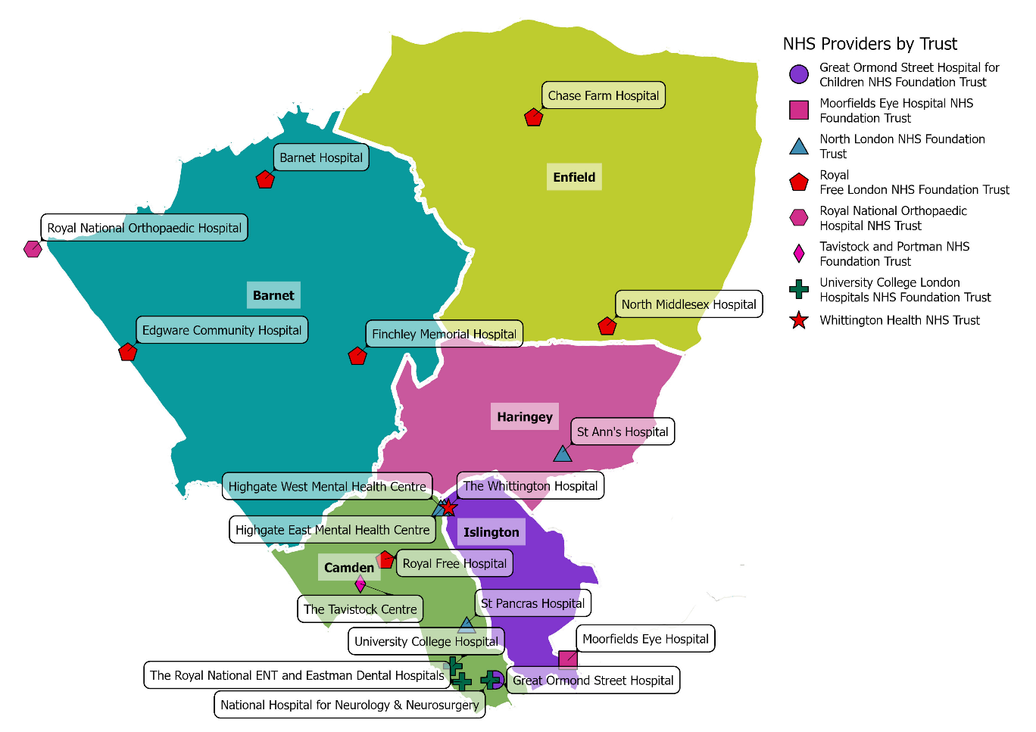
We are home to internationally recognised centres of medical excellence and expertise, specialist NHS providers, and a number of renowned academic and research institutions. Together we are working hard to ensure that everyone has fair access to high quality health and care services at every stage of their lives.

North Central London Integrated Care Board (NCL ICB)

We are the NHS statutory organisation that plans, coordinates and commissions activity across the North Central London ICS. This means we decide how the NHS budget in our area is spent. We join up health and care services and work in partnership with local councils, the voluntary and community sector and local NHS providers to achieve value for money. Our mission is to improve the health, care and wellbeing of residents across our five boroughs and to tackle inequalities in access, experience and outcomes.
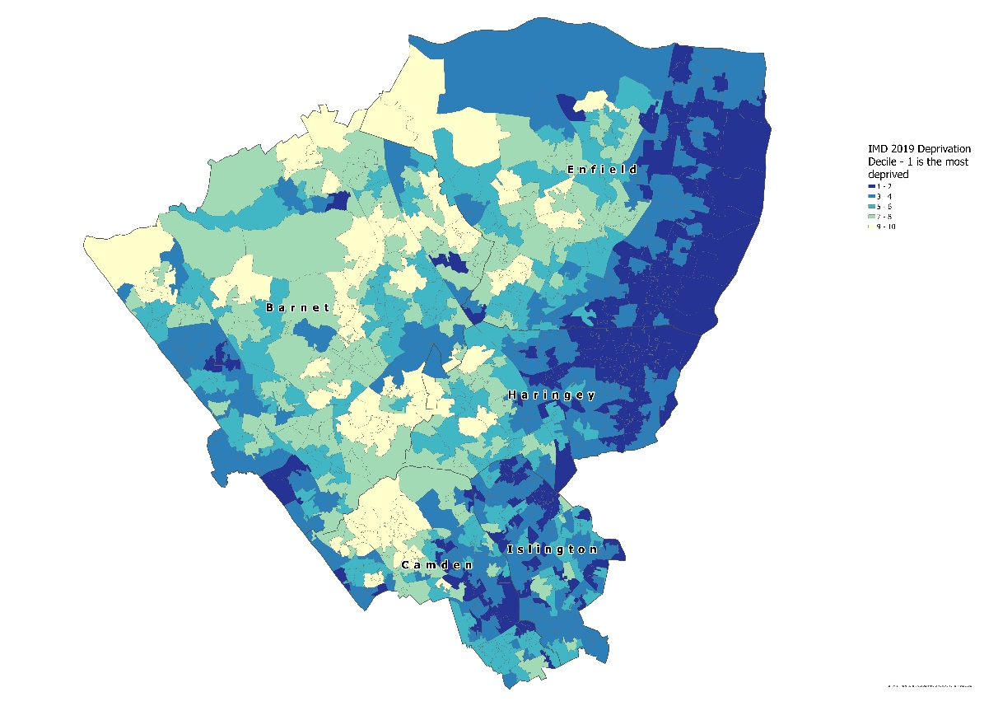
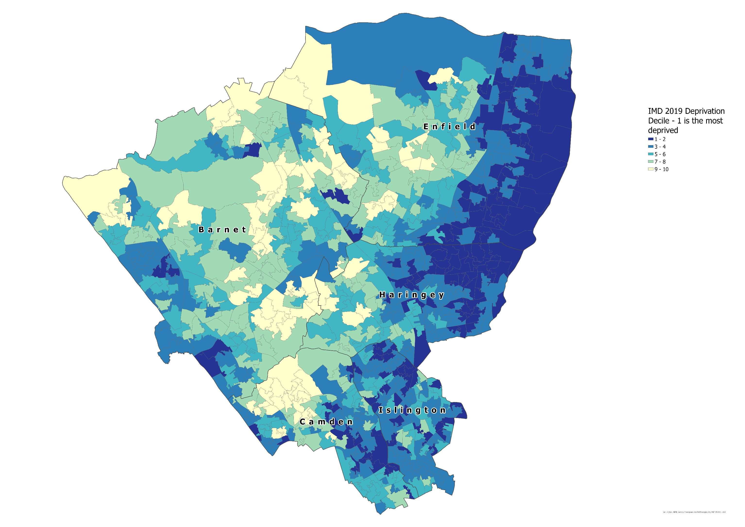
North Central London is the second most deprived ICS in London, with areas of deprivation across all five boroughs that are often in close proximity to areas of affluence.

More than half of the population lives in the 40% most deprived areas nationally, and more than one in 10 households across NCL are in fuel poverty, rising to over 15% in Haringey.

There are also distinct patterns of deprivation with concentrations towards the east of NCL,
with Enfield, Haringey and Islington having on average higher levels of deprivation.

A significant portion of our residents remain unregistered, including those from ‘inclusion health groups’ (for example, people experiencing homelessness, refugees and asylum seekers and sex workers).

Ambition and aims

Our Ambition

As an integrated care partnership of health, care and voluntary sector services, our ambition is to work with residents of all ages in North Central London so they can have the best start in life, live more years in good physical and mental health in a sustainable environment, to age within a connected and supportive community and to have a dignified death.

We want to achieve this ambition for everyone.

Working with our residents, patients, and partners, we have developed an ambitious Population Health and Integrated Care Strategy which reflects a significant change in our approach to the health and care system.

The strategy aims to:
- Reduce health inequalities – working together to identify unmet needs across our different communities and address them with services and support that are accessible and inclusive.
- Focus on prevention, early intervention, and proactive care – empowering people to stay healthy and acting early when people are at risk of becoming unwell.
- Work together as a system – making sure that our services, people, data and wider resources are joined up and that actions are taken based on what our residents are telling us. We want to build on the great work that is already happening in pockets of North Central London and work together to tackle the wider causes of avoidable poor health (including inadequate housing or environmental issues).

Key strategic capital schemes

Providers

The table below represents all locally funded strategic capital schemes. They are part of a multi-year investment programme, and many will also have other sources of funding not noted here. There are additional strategic schemes within the ICS that are funded by national money (eg Moorfields Oriel) or large charitable donations (GOSH Children's Cancer Centre).

25/26 Strategic schemes | Org. | £m
Electronic Patient Record | MEH | 0.50
Electronic Patient Record | NLFT | 0.77
Electronic Patient Record | RNOH | 3.60
Electronic Patient Record | WHIT | 5.50
Neighbourhood Care allocation | ICB | 9.16
UCLH Neonatal Expansion | UCLH | 0.98
Start Well | RFL | 1.86
Start Well | WHIT | 3.51
St Pancras Transformation Programme | NLFT | 21.60
Total |  | 47.48

Note the above table is a view of strategic schemes allocations post-planning submission as key decisions on Start Well and St Pancras had yet to be made. Subsequent tables in this document do not reflect the above allocations.

ICB

The ICB retains a portion of provider operational capital to invest in Neighbourhood care. The following projects have been delivered recently or are under development.

Borough | Scheme | Description
Barnet | Torrington Health Centre | Significant reconfiguration of this existing health centre to deliver space for a new practice.
Barnet | Finchley Memorial Hospital Community Diagnostic Centre | Major capital programme to establish a community diagnostic centre, incorporating new MRI, CTs and other capabilities.
Camden | Hunter St | A significant refurbishment of an existing health centre, enabling relocation of a GP practice & additional community care capacity.
Camden | Kentish Town | Establishment of an Integrated Neighbourhood Hub in this core health centre.
Enfield | Evergreen | A major refurbishment of this health centre, to improve overall quality on lease expiry for 3 GP practices & 2 Trusts.
Enfield | White Lodge & Alma Lodge | A major investment into these 2 GP practices.
Haringey | Welbourne | A new health centre at the heart of this council led regeneration scheme.
Haringey | Green Lane | Another new health centre for GP services on the ground floor of this housing development.
Haringey | Muswell Hill | A conversion of existing commercial space for GP services.
Haringey | Wood Green Community Diagnostic Centre | Conversion of retail space into a new Community Diagnostic Centre, with MRI, CT, ophthalmology and others.
Islington | Andover | A conversion of a council owned office building for GP services.
Islington | Holloway | A major refurbishment of this health centre for GP services.
NCL | Digitisation of patient records | A wider programme that has converted 35+ storage rooms into usable clinical space.
NCL | Local Investment Grant funding | A multi-year programme that has improved access & quality across 20+ GP buildings.

Capital and Estates governance

Capital

Capital allocations are set during planning and are approved by the ICB and Trust Chief Financial Officers (CFOs), the System Management Board (system CEOs) and the NCL ICB Finance Committee. In-year reprioritisations are approved by system CFOs. These groups also oversee monthly monitoring of spend.

Prioritisation of spend within Trusts is done by the organisations themselves and each organisation has their own capital and estates governance structure – see section on ‘Capital prioritisation’.

Estates

Strategy

NCL ICS was identified as a vanguard for its Estates and Infrastructure Strategy in 2023. The 2024 Estates Strategy followed with key headlines being:
- It built on our 2023 Estates Strategy and Place Master planning
- Continued alignment between the ICB strategy and provider strategies
- Continued operational capital top-slice put towards delivery of Local (Neighbourhood) Care & left shift
- Longer-term capital planning was central, aligning estates & finance teams across the system. This included
  - Consistent process and criteria to identify transformation priorities
  - Visibility over BAU capital including risk managed backlog
- Investment principles to drive consistency as to how capital is allocated
  - Fuller, primary care ambitions and Integration key to that delivery
- Ensuring commissioner, system & place all involved in prioritisation process
- Importance of building the evidence on return on investment
- Actions to improve system efficiency & productivity, such as
  - Filling expensive community voids
  - Optimising use of expensive NHS Property Services / Community Health Partnerships estate
  - Enabling disposal of our “tail” estate (poor quality estate that is not fit for purpose), including primary care “recycling value”

The result being that NCL ICB has opened two new health centres a year since 2021. The new facilities make a significant difference in local communities, supporting the Neighbourhood Care agenda. We have also embraced the community diagnostic centre initiative, establishing two award-winning centres.

The Estates team

The NCL Estates team works at both NCL and borough level. It seeks to create a consistent approach to NHS property across NCL, to support excellent health and care outcomes across neighbourhoods and communities while also being mindful of wise spending.

The focus of the team’s role is to work collaboratively with estate leads across the system, including providers, PCNs, councils, and other partners, to innovate, share best practice and maximise the sharing of resources in NCL. This includes looking at the best locations for services, value for money in procurement and construction, making the best and most efficient use of buildings and land, population health needs and future flexibility.

The graphic below sets out how estates governance works in NCL.
ICB Board Committee
Engagement Forum
Programme Delivery Board
Sub-committee with delegated decision-making
Strategy and Development Committee
Local Care Infrastructure Delivery Board
Finance
Committee
Barnet
Estates Oversight Group
Camden PC Oversight Group
Enfield
Estates Oversight Group
Haringey Estates Oversight Group
Islington Estates Oversight Group
Barnet
Local Estates Forum
Camden
Local Estates Forum
Enfield
Local Estates Forum
Haringey
Local Estates Forum
Islington
Local Estates Forum

Primary Care Committee
NCL Estates Board

2025/26 CDEL allocations and sources of funding

CDEL funding allocation

NCL has been allocated £230m of CDEL in 2025/26 across Providers and the ICB to cover capital expenditure and leases. This is based on the national capital allocations formula. NCL has additionally earned £42m of operational capital bonuses: £22m for delivering a balanced revenue position in 2024/25 and £20m for submitting a balanced financial (revenue) plan for 2025/26. This brings the total operational capital budget to £272.8m for 2025/26.

NCL also expects to receive c.30m of national funding for schemes relating to the Government’s aim of returning to constitutional standards across diagnostics, urgent and emergency care, and electives and £19m to address the most pressing critical infrastructure risks to improve estates safety – both subject to business case approval.

The system will also receive £118m to support Oriel at Moorfields as part of the New Hospital Programme, £12m for provider Electronic Patient Records systems and £17m on a variety of smaller schemes eg replacement of Linear Accelerators.

Please see the Appendix for detailed system CDEL allocations.

25/26 Capital allocation | £'000
System operational capital
Providers | 227,172
ICB | 3,342
2024/25 Revenue Fair Shares Allocation Adjustment | 22,225
2025/26 Revenue Fair Shares Allocation Adjustment | 20,018
Total operational | 272,757
National programmes
Return to Constitutional Standards | 30,250
2025/26 Estates Safety | 19,634
New Hospital Programme | 118,274
Technology Schemes (Frontline Digitisation) | 12,511
Other | 16,590
Total national | 197,259
Total | 470,016

Capital risks

Category | Risk | Mitigations
Regulatory and Approval Delays | Delays related to Building Safety Act (BSA) approvals are significantly affecting project timelines and adding compliance-related design costs. | - Early engagement with regulators  - Use of modular or pre-approved design elements  - Including time contingency within programme plans, reviewed regularly
Regulatory and Approval Delays | Other planning and regulatory approvals are also slow, pushing project starts and increasing delivery uncertainty.
Cost Inflation and Market Conditions | Construction and consultancy cost inflation is driving up tenders and challenging affordability. | - Cost benchmarking and market testing  - Scope prioritisation  - Use of procurement routes that allow market-responsive pricing and phasing  - Value engineering  - Active supplier dialogue, reviewing programme phasing to manage affordability
Cost Inflation and Market Conditions | Contractors are incorporating inflation contingencies, which affect programme scope and procurement timelines.
Funding Constraints | Capital and revenue funding limitations are restricting the ability to deliver or start new schemes. | - Phased delivery strategies  - Mixed funding models (National / System / Charity / Disposals)  - Pipeline review and prioritisation  - Assess funding implications early in business cases; consider alternative financing / phasing options  - Maintain robust risk registers
Funding Constraints | Some projects cannot be capitalised (eg SaaS solutions), placing additional pressure on revenue budgets and delaying transformation initiatives.
Funding Constraints | Low capital envelopes mean that any unplanned needs may halt or scale back ongoing projects.
Delivery and Implementation Risks | Risks of slippage in programme delivery due to delays in supplier or contractor mobilisation. | - Readiness and mobilisation assessments; detailed mobilisation plans; phased works; clinical impact assessments; joint planning with clinical teams.  - Early sequencing and stakeholder engagement; separation of works from care areas; use of decant space.  - Schedule contingency; prepare procurement documentation early.
Delivery and Implementation Risks | Logistical and coordination challenges when delivering projects in live clinical environments.
Delivery and Implementation Risks | Compressed delivery timelines due to late approvals are increasing the risk of programme failure.
Procurement and Cyber Risks | Information governance or cyber security issues may arise during IT procurement or implementation phases, impacting timelines and security posture. | - Data Protection Impact Assessments  - Cyber and IG Due Diligence in Supplier Evaluation  - Clear Governance gateways  - Training and awareness
Estates management | Failure to achieve void reductions means that ongoing revenue costs of new buildings cannot be supported. | - Implement occupancy planning processes to reduce the likelihood and impact of voids  - Active implementation of disposals strategy  - Stakeholder engagement and communications
Estates management | Challenges in closing "tail" premises with GP practices remaining in contract and local stakeholder opposition.
IFRS 16 Leases | Recognition of leases are difficult to forecast and manage proactively making management across the system difficult. | - Pooled budgets  - Use system-wide forecasting and shared monitoring to anticipate lease impacts

Capital prioritisation

Setting operational and strategic allocations

Operational capital

Our approach to allocation is underpinned by principles of equity, strategic alignment, and deliverability, ensuring that investment supports both immediate operational needs and longer-term transformation.

The ICB sets provider allocations using the national capital allocations formula which takes into account depreciation, backlog maintenance and gross assets.

The total provider allocation pot is then top-sliced to fund two schemes:
- Strategic schemes – a 10% top-slice is applied to fund strategic capital schemes (see section above). Half of this top-slice is returned to providers to fund relevant strategic schemes and the other half remains in the ICB to fund local care (Neighbourhood) schemes.
- IFRS 16 – a notional £44m top-slice (based on prior year spend) is applied to pool resources to meet IFRS 16 needs. Given the bumpy nature of lease recognition, a pooled budget was agreed with Trusts. This funding is allocated to providers based on forecasted spend.

In-year reprioritisation

The ICB runs a capital deep dive at M06 to understand the current and forecasted capital spend within the system. Capital is then reprioritised to ensure full use in-year. Deep dives occur again later in the financial year to make best use of capital in the final months.

Provider process

Providers each have their own internal process for capturing capital priorities, evaluating them and prioritising them. Broadly, providers use the following principles:

Key Inputs & Considerations:
- Risk Registers
- Regulatory Reports – CQC recommendations, compliance audits
- Asset Condition & Lifecycle – Planned replacement due to age, degradation, backlog maintenance
- Clinical / Service Impact – Impact on patient care, outcomes, service delivery
- Financial Constraints – Alignment with available capital funding and revenue consequences
- Strategic Alignment – Links to Trust objectives, national plans, and technology/digital strategies

Risk-Based Focus:
- Safety – Patient / staff safety, clinical service cancellation / delay, critical infrastructure risk, fire safety
- Compliance – Meeting regulatory standards (CQC), legal / contractual commitments, mandatory requirements
- Operational Continuity – Preventing service disruption or collapse

Assessment, Governance & Approval:
- Most trusts use formal frameworks
- Dedicated Capital Planning Groups / Committees
- Executive Oversight – Proposals typically reviewed and approved by executive / senior leadership and boards

Strategic capital

With agreement of all partner Trusts, NCL ICS allocates 10% of its operational capital allocation to system priorities that are locally funded and too large for any single organisation to afford within their regular operational capital allocation. This allows the ICS to pool resources to address system-wide strategic challenges.

In addition to the allocation for strategic schemes, NCL ICS has also allocated its 24/25 and 25/26 capital bonuses – earned for delivering a balanced plan in 24/25 and submitting a balanced plan in 25/26 respectively – to strategic schemes.

Strategic schemes are generally Provider led and therefore will have gone through internal prioritisation and governance, usually with some ICB involvement.

Providers put forward strategic schemes that would be unaffordable within their own operational capital limits. A programme of schemes is put together by the ICB, mostly ongoing schemes and some new, and affordability is assessed based on the level of strategic capital available. A proposed programme of schemes is then agreed by system CFOs.

Neighbourhood Care

The neighbourhood care allocation is prioritised in the following way

Process
Outputs
Draft pipeline of schemes for strategic review
Longlist of schemes & top priorities for strategic sign-off
Prioritised Investment Delivery Pipeline & Comprehensive Development Pipeline

Prioritising national schemes

Bids for national funding are managed through specific system groups eg Diagnostic Networks for digital diagnostics and diagnostic capacity funding. These expert groups understand the system need, support Trusts to submit bids to the ICB and support the ICB in assessing bids before submitting to NHSE.

Capital planning

Planned spend
Expenditure category | ICB | GOSH | MEH | NLFT | RFL | RNOH | T&P | UCLH | WHIT | Total
 | £'000 | £'000 | £'000 | £'000 | £'000 | £'000 | £'000 | £'000 | £'000 | £'000
Backlog Maintenance - Moderate and low risk |  | 2,037 |  |  |  |  | 74 |  | 1,000 | 3,111
Backlog Maintenance - Significant and high risk (CIR) |  | 8,728 | 621 | 18,379 | 8,000 | 2,195 | 1,105 | 11,606 | 3,917 | 54,551
Routine maintenance (non-backlog) - Land, Buildings and dwellings |  | 1,005 |  |  |  |  |  | 7,220 |  | 8,225
Fire safety |  | 120 | 250 |  |  |  |  |  | 7,586 | 7,956
Plant and machinery |  |  |  |  | 6,595 |  |  |  |  | 6,595
Equipment - clinical |  | 12,207 | 1,014 |  | 3,883 | 206 |  | 22,170 | 17,701 | 57,181
Equipment – non-clinical |  |  |  |  |  |  | 183 |  |  | 183
IT - Clinical Systems |  | 595 | 11,377 | 834 | 5,000 | 11,833 | 100 |  |  | 29,739
IT - Cybersecurity, Infrastructure/Networking, Telephony, Hardware, Other |  | 3,434 | 200 |  | 5,000 | 7,998 | 3,155 | 7,200 | 1,000 | 27,987
New Build - Diagnostics, Land, buildings and dwellings, Multiple areas, Non-clinical, Other |  | 56,242 | 150,772 | 16,300 | 6,433 | 7 |  | 24,230 | 11,233 | 265,217
Other - including investment property and intangible assets |  | 8,584 |  | 3,389 | 49,104 |  |  | 13,516 |  | 103,842
GPIT | 2,000
Primary Care | 13,293
Strategic schemes reserve | 29,249
Total | 44,542 | 92,952 | 164,234 | 38,902 | 84,015 | 22,239 | 4,617 | 85,942 | 42,437 | 579,880

Note: the table above shows the planned spend as of the time of the financial planning submission hence the existence of a row labelled ‘Strategic schemes reserve’. At this point in time key decisions on some strategic schemes had not been made. This reserve has now been allocated to specific schemes – see ‘Key strategic capital schemes section’ above.

Backlog maintenance and Critical Infrastructure Risk

Backlog maintenance and Critical Infrastructure Risk are priority areas for investment by Trusts and the ICB. Planned investment has grown by c.50% over 24/25 spend of £41.5m.

Category | GOSH | MEH | NLFT | RFL | RNOH | T&P | UCLH | WHIT | Total
 | £m | £m | £m | £m | £m | £m | £m | £m | £m
High and Significant | 9.4 | 0.69 | 12.79 | 87.12 | 16.94 | 8.58 | 179.81 | 14.34 | 328.98
Moderate and Low | 2.94 | 5.32 | 11.58 | 68.05 | 17.38 | 0.26 | 73.23 | 0 | 173.44
Total backlog maintenance and CIR | 12.34 | 0 | 24.37 | 155.17 | 34.32 | 8.84 | 253.04 | 14.34 | 502.42
25/26 planned spend to address backlog | 10.77 | 0.62 | 10.86 | 12.1 | 1.33 | 1.53 | 11.61 | 13.21 | 62.03

Note: the Whittington figure includes £7.6m of national investment from the Estates Safety fund.

Overview of ongoing schemes and NHSE business cases in 2025/26

Below is a list of schemes above £10m in capital value, some of which will require a business case to be submitted to NHSE in 2025/26. There are also smaller business cases being submitted to NHSE as part of approvals for national funds eg Return to Constitutional Standards and Estates Safety.

Capital values are subject to change as are funding sources as programmes progress. Revenue funding is not included.

Org. | Scheme description | Scheme capital value and sources of funding  £m
GOSH | Children’s Cancer Centre  The centre will be a step change for GOSH cancer services. Currently, the cancer wards and day care services are spread across different buildings in the older parts of the GOSH estate, meaning it can take up to 20 minutes to get between them. Some of the buildings are over 30 years old, with some of the hospital’s most seriously ill patients undergoing chemotherapy being treated in Safari Ward in the 1930’s Southwood Building.  The new Children’s Cancer Centre will bring together the different services needed for specialist cancer care, allowing teams to work more closely together. This will improve the quality of care, reduce risk and allow rapid access in emergencies. These services will also support other specialities from across GOSH, meaning everyone will benefit. | £361m  System:  £31.3m  Charity:  £330m
MEH | Oriel  Oriel is a joint initiative between Moorfields Eye Hospital NHS Foundation Trust, UCL Institute of Ophthalmology and Moorfields Eye Charity. Together, they will relocate all services at Moorfields Eye Hospital on City Road and the UCL Institute of Ophthalmology on Bath Street, to a new, integrated centre in Camden. | £415.4m  National:  £150.3m  System:  £200.1m  Charity:  £65m
MEH | Electronic Patient Record  MoorConnect is a major digital transformation programme deploying a cloud based EPR across all Moorfields sites. | £18.1m  National:  £16.6m  System:  £1.5m
NLFT | St Pancras Transformation Programme  St Pancras Hospital was built in 1848 and proposals have been underway for several years to redevelop the site and use the proceeds from land sales to deliver brand new healthcare facilities for patients across Camden and Islington.  Through these proposals, the NHS is looking to transform the mental and physical healthcare services that patients in North Central London receive. | £276.5m  National:  £80m  System:  £196.5m
NLFT | Electronic Patient Record  Implementation of the Rio EPR system. | £7.8m  National:  £3.9m  System:  £3.9m
RFL | Barnet redevelopment  This scheme expands the Emergency Department footprint at Barnet Hospital, including a new front door, Urgent Treatment Centre, ambulance handover area, and separate paediatrics flow to improve operational performance and patient experience. | £12.7m  National:  £5.5m  System:  £7.2m
RFL | Generator replacement  Replacing temporary generators currently supporting the Royal Free Hospital with four permanent units, improving site-wide power resilience and mitigating business continuity risk. | £24.7m  System:  £24.7m
RFL | Hybrid Theatres  Construction of two new hybrid theatres at Royal Free Hospital, replacing non-compliant existing theatre and enabling the creation of a vascular centre of excellence. Includes plant and shell/core works across multiple levels.  A business case will be submitted to NHSE for this programme in 2025/26. | TBD
RNOH | Electronic Patient Record  Procurement of the Epic EPR system, in partnership with UCLH. | £28.1m  National:  £17.1m  System:  £11m
ULCH | Gray’s Inn Road  A new world class centre of excellence for neuroscience will open in 2026 on Gray’s Inn Road. The project will combine UCL's Queen Square Institute of Neurology and the headquarters of the UK Dementia Research Institute, providing an expansion of MRI capacity (four additional MRI scanners for the NHS and 1 for research) and a new outpatient facility. | £13.9m + TBD IFRS 16 charge  System:  £8.7m  Charity:  £5.2m
ULCH | Bedford Passage  Bedford Passage is a mixed-used development project, located in Fitzrovia off Cleveland Street. It will provide a new home for the UCLH breast clinic and additional MRI imaging services, as well as residential and commercial units. | £14.2m + TBD IFRS 16 charge  System:  £8.9m  Charity:  £5.2m
WHIT | Fire remediation  To remediate critical fire risks identified in Blocks A& L following a fire in Block A in January 2018. | TBD
WHIT | Power Infrastructure Project  Upgrade power running through Whittington Hospital from 2600 KVA to 8500 KVA to supply enough power for major new development projects. This additional power will move the hospital away from fully relying on fossil gas fuel as the primary source for heating, to a modern electric heat pumps supply of green electricity. By completion of the project Whittington will be looking at an incredible 80% decrease in carbon emissions. The project will also help Whittington save £15k on their annual electricity consumption by 21,000Kwhrs. | £65m  TBD
WHIT | Electronic Patient Record  A programme to replace or extend its current hospital and community clinical record solutions.  A business case will be submitted to NHSE for this programme in 2025/26. | TBD
Cross-system | Start Well  A cross-system programme to address declining births across North Central London so that services can meet the changing and more complex health needs of babies and pregnant women and people, and also to address inequalities. The changes, agreed by NCL ICB and NHSE include:  - Additional investment in maternity and neonatal services, with care delivered at University College London Hospitals, Barnet Hospital, North Middlesex University Hospital, and Whittington Hospital.  - Eventual closure of maternity and neonatal services at the Royal Free Hospital. This will not be for several years.  - Eventual closure of the birthing suites at Edgware Birth Centre, while enhanced and expanded antenatal and postnatal care will be available at the site.  Whittington will submit a business case to NHSE for their investment in Start Well in 25/26. | £85.4m  System:  £85.4m

Explanation of funding sources:
- National – capital provided by NHS England or DHSC, this may also be as a loan.
- System – capital provided by the Trust themselves, either through their regular CDEL allocation or disposals, this may also include capital provided by other Trusts or the ICB.
- Charity – capital provided by charities, usually those linked to the Trust or large national organisations.

Cross-system and collaborative working

Local Authorities

Local Authorities are a vital strategic partner in delivering NCL’s infrastructure strategy. The ICB has established borough partnership teams in each of NCL’s
five boroughs, working closely with a designated estates lead.

The ICS has numerous estates interactions with its constituent local authorities
Where the NHS can divest from estate, opportunities for affordable housing projects are explored to support local authorities to meet targets. St Ann’s Hospital in Tottenham is a good example, with more than 900 new homes being constructed on land surplus to NHS requirements which was sold to the Greater London Authority in 2018 by NLFT (then BEH Mental Health Trust). The Trust continues to support patients on the retained part of the St Ann’s site, operating from a reduced and higher quality footprint.

Local Authority voids also potentially provide a “win-win”, in that the NHS can secure much needed local estate while providing the Local Authority with important revenue.

The ICB is currently working jointly with Local Authorities on several Primary Care / Local Care developments eg with Islington Council on the relocation of Andover Medical Centre to Newington Barrow Way.

Other partners

The ICB Estates team works in close partnership with estates teams in the Trusts, who are responsible for the vast majority of ICS capital spend.

The ICB also works closely with NHS Property Services (NHSPS) who manage 33 properties across the NCL estate. NHS Property Services’s key focus to 29/30 includes:
- Taking forward key requirements / developments working with ICB and Local Authorities
- Completion of Hunter Street, Edgware Community Hospital, Torrington and next phase assessment for Finsbury Health Centre
- Further exploration of potential for surplus land disposals and NCL estate reinvestment informed by Core, Flex and Tail reviews
- Continue collaboration between NHSPS and ICB to reduce vacant / void space across NCL

Net zero carbon strategy

ICB strategy

The North Central London Green Plan 2025–2028 is led at a system level and reflects the collective ambitions and activities of organisations across the Integrated Care System. Each NHS Trust within NCL will have its own individual Green Plan, which complements and aligns with the wider ICS approach to sustainability.

The delivery of the 2022–2025 NCL Green Plan was underpinned by a distributed leadership model, with each priority area co-led by senior leaders from across NCL organisations. This reflects our commitment to a collaborative, system-wide approach. This model has laid a robust foundation for the 2025–2028 Green Plan, where we will continue to strengthen this structure, deepen integration, empower leadership at all levels, and accelerate delivery across the system.

The strategy has 8 areas of focus for the next three years:

Area of focus | Rationale
Net Zero Clinical Transformation | Clinical care accounts for around 40% of the NHS’s carbon footprint, making it a critical area for decarbonisation. Without embedding carbon reduction into clinical decision-making and service redesign, we risk missing key opportunities to provide more sustainable care — such as switching to low-carbon treatments, avoiding unnecessary procedures, and optimising patient pathways.
Digital Transformation | Strong digital foundations are essential for transforming care by improving access, quality, and productivity while delivering against the NHS’s net zero targets. However, we are also mindful of the environmental impact of digital services, particularly the energy demands of data storage, electronic patient records and the carbon footprint of outdated digital infrastructure. We are committed to adopting energy-efficient technologies, leveraging cloud-based solutions with lower emissions, and ensuring that digital advancements contribute to both improved patient outcomes and environmental stewardship.
Medicines | Medicines contribute to 23% of NCL’s carbon footprint, with the majority of these emissions resulting from the procurement of medicines. However, the prescribing, use and disposal of medicines also represent a significant opportunity to reduce emissions and embed sustainability across health and care. To meet NCL’s net zero ambitions, we must reduce unnecessary prescribing, switch to lower-carbon medicines where clinically appropriate, and support better use and disposal practices. Embedding sustainability into medicines optimisation not only reduces emissions but can also enhance patient care and reduce waste across the system.
Travel & Transport | The NHS accounts for 3.5% of all UK road traffic, with patient, staff, and supply chain transport generating significant emissions and air pollution. Addressing this is a priority for NCL if it is to achieve its net zero targets. We need to transition to more sustainable travel options for staff, patients, and goods but there are economic, behavioural and structural barriers that makes this difficult.
Estates & Facilities | The NHS estate plays a pivotal role in achieving a greener, more resilient health system. Estates and facilities are by far the largest contributors to NCL’s carbon footprint, with energy use alone accounting for 13% of our total emissions. This makes decarbonising our buildings not only an environmental imperative, but a strategic priority for our region’s sustainability efforts.
Supply Chain & Procurement | Over 60% of the NHS’s carbon emissions are linked to its supply chain, influenced by factors such as carbon-intensive manufacturing, single-use products, and logistical inefficiencies. In North Central London, procurement practices often involve suppliers who may not yet have clear Net Zero commitments, which can make it more challenging to align fully with NHS sustainability ambitions.
Adaption | Climate change poses an urgent and increasing threat to the NHS’ ability to deliver safe, effective, and equitable care. It is already placing growing pressures on services, affecting health outcomes in particularly vulnerable populations such as the elderly, those with respiratory and cardiovascular conditions, and people living in deprived areas.
Workforce | Workforce is a key enabler for the successful implementation of the NCL Green Plan 2025–2028. Our people, whether in clinical, operational or support roles, are central to driving the cultural and behavioural change required to deliver a more sustainable health and care system. Equipping, empowering, and engaging staff will be essential to meeting our environmental goals while continuing to improve population health and reduce inequalities.

Read the full plan to learn more about our progress to date on these areas of focus and opportunities going forward:
https://nclhealthandcare.org.uk/ics/our-plans/ncl-green-plan/

How the capital plan supports net zero

Providers in NCL are investing in schemes that are directly or indirectly addressing Net Zero:

- Backlog maintenance improves estates which may result in greater energy efficiency.
- Sustainability is embedded in plans for new builds / developments such as St Pancras and Oriel.
- Whittington Power Infrastructure project aims to deliver cleaner power to the hospital.
- Providers have been successful in applying for national solar panel funding.

Appendix A: System CDEL table
CDEL | ICB | GOSH | MEH | NLFT | RFL | RNOH | T&P | UCLH | WHIT | Total full year plan £’000 | Narrative on main categories of expenditure
Operational Capital – ICB | 12,499 | - | - | - | - | - | - | - | - | 12,499 | £9m investment in strategic local care schemes
Operational Capital – Provider | - | 35,262 | 15,310 | 36,217 | 67,104 | 12,027 | 2,774 | 73,631 | 17,933 | 260,258 | Various schemes
Total System Operational Capital | 12,499 | 35,262 | 15,310 | 36,217 | 67,104 | 12,027 | 2,774 | 73,631 | 17,933 | 272,757
2025/26 Cancer LINAC Replacement | - | - | - | - | 2,616 | - | - | 2,616 | - | 5,232
2025/26 Estates Safety | - | 2,400 | 250 | 2,621 | 4,054 | 1,795 | - | 924 | 7,586 | 19,630 | £7.6m investment by Whittington for fire safety improvement
Diagnostics | - | 1,852 | 64 | 64 | 372 | 184 | 63 | 3,948 | 15,609 | 22,156
Elective Recovery/Targeted Investment Fund | - | 66 | - | - | 895 | - | - | 897 | 892 | 2,750
Net Zero (GB Energy Solar) | - | - | - | - | 2,541 | - | - | - | 417 | 2,958 | £2.5m investment by Royal Free as part of the Solar Partnership Scheme
NHP | - | - | 118,274 | - | - | - | - | - | - | 118,274 | Project Oriel at MEH, part of the New Hospital Programme
Technology Schemes | - | - | 4,278 | - | - | 8,233 | - | - | - | 12,511 | Front Line Digitisation programmes
UEC Capacity | - | - | - | - | 6,433 | - | - | 1,816 | - | 8,249 | £6.4m investment by Royal Free as part of Barnet UTC redevelopment
Other Adjustments - Provider | - | - | - | - | - | - | - | 2,676 | - | 2,676
Total System CDEL | - | 39,580 | 138,176 | 38,902 | 84,015 | 22,239 | 2,837 | 86,508 | 42,437 | 454,694
Return to Constitutional Standards: Diagnostics (system allocation only) | - | 1,788 | - | - | 112 | 120 | - | 1,802 | 15,404 | 19,226 | As above
Return to Constitutional Standards: Elective Recovery | - | 66 | - | - | 895 | - | - | 897 | 892 | 2,750
Return to Constitutional Standards: UEC | - | - | - | - | 6,433 | - | - | 1,816 | - | 8,249 | As above
Return to Constitutional Standards Total | - | 1,854 | - | - | 7,440 | 120 | - | 4,515 | 16,296 | 30,225

https://nclhealthandcare.org.uk/our-working-areas/population-health/
Tavistock and Portman NHS Foundation Trust is currently undertaking a 6-facet survey for the 24/25 Estates Return Information Collection therefore the figure for backlog maintenance in the table is from the 23/24 collection. An updated figure will be available in October 2025.
https://www.gosh.nhs.uk/about-us/redevelopment/childrens-cancer-centre/
https://oriel-london.org.uk/
https://www.northlondonmentalhealth.nhs.uk/st-pancras-transformation-programme/
https://www.uclh.nhs.uk/about-us/new-developments
https://www.uclh.nhs.uk/our-services/our-hospitals/bedford-passage
https://www.whittington.nhs.uk/default.asp?c=46612
https://nclhealthandcare.org.uk/get-involved/start-well/
https://nclhealthandcare.org.uk/wp-content/uploads/2025/07/NCL-Green-Plan-2025-28.pdf
https://nclhealthandcare.org.uk/wp-content/uploads/2022/04/North-Central-London-Green-Plan-2022-2025.pdf

