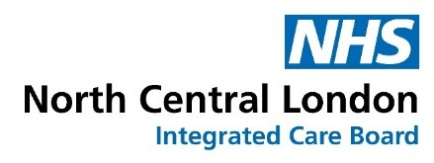

Community Connectors for MMR engagement commissioning brief

Project overview

The North Central London (NCL) Vaccination Transformation team would like to commission a programme of community engagement in Enfield and Haringey with the goal of increasing understanding and uptake of the MMR vaccine among communities under-represented in our uptake figures.
We would like to follow and build on the engagement approaches used in existing community connectors programmes in NCL including the Community Connector hypertension programme, Community Action Research, Research Engagement Network, Prostate Health and Health Heroes Unit and Groundworks’ Healthy Hearts programme which supports our population health improvement and integrated care strategy by connecting CORE20PLUS5 communities, people and their families on heart health and prevention, alongside understanding key issues and priorities that matter to our local communities.
This project aims to tackle health inequalities by focusing on the most underserved communities which data show lie between these two boroughs. Although our focus will be on MMR and other childhood immunisations, communities have welcomed more holistic support with their health and wellbeing. As such, the programme intends to provide more general information about child and family health. We are keen the programme is shaped with local communities – both on the delivery approach and overarching health priorities. We are seeking the successful applicants to develop a community connecting programme – working with community leaders that can break down barriers and explore behavioural changes, that support improved health outcomes, within their respective communities. The funding should be used to ensure as many people as possible within these areas can be reached (with an offer of health checks, continued support, education and awareness and promotion of childhood immunisations as well as catch-up vaccination clinics).

We are looking to work with a lead facilitating voluntary and community sector (VCSE) organisation and a group of grassroots organisations – working as a joint VCSE Partnership - that are best placed to support the community connector ambition around the defined priority areas.

Programme aims and objectives
- Build a strong VCSE partnership, bringing together a lead facilitating organisation and grass roots organisations – equitably sharing funding and utilising the unique skills of each organisation to work with local communities
- Develop a simple training programme to upskill the VCSE partnership’s and community connectors’ knowledge of the key priority areas
- Recruit and support community connectors within relevant wards across communities
- Empower communities to manage their health/increase access to services
- Raise awareness of the dangers of measles and the benefits of MMR vaccination, maternal whooping cough vaccination and other childhood vaccinations as well as holistic family health messaging. Alleviate people’s fears over misconceptions around vaccinations and support them to be up to date with all vaccines
- Signpost to catch-up clinics and help book appointments for these.
- Gather key information about community barriers to accessing healthcare and vaccines
- Offer education within communities to embed learning and build legacy.
- Increase understanding in target communities around how to access health advice and services; self-care, when to seek help and how
- Achieve a higher uptake of childhood immunisations, particularly MMR
- For commissioners to have increased understanding of community needs
- Collaborate with and amplify the voices of local communities who experience high health inequalities and/or barriers to accessing services through targeted community participatory research delivered through the VCSE
- Meet communities where they are so they can also raise issues which matter to them and set outcomes which are meaningful for their lives
- Work in collaboration with the Primary Care Networks (PCNs), so local practice nurses can also attend events (will be able to answer more challenging questions as well as check patient records)
- Work with partners to identify key events for the involvement of clinical and administrative general practice staff at events where appropriate
- Ensure cross borough learning and the ability to embed change effectively based on these.
- Ensure we work together with other relevant community champion programmes locally to join up our messaging and not duplicate work.

Our long-term aim is the increased uptake of vaccinations, especially in our targeted communities (outlined below), greater awareness of health services and improved health outcomes for communities who experience health inequalities and/or barriers to access.

Priority connecting areas:

MMR
Focusing on the most deprived wards across the boroughs – raising awareness of the dangers of measles and how measles is prevented through MMR vaccination only.

Childhood Immunisations
Ensuring people are aware of the schedule of vaccination and know how to get vaccinated to ensure they and their children stay well.

Wider Family Health Offer
Ensuring families are aware of a range of health and wellbeing offers including signposting to information and services.

Reporting
The lead facilitating organisation needs to support the collation of, and provide records and reporting on:

- Number of people spoken to
- Number of events organised
- Number of vaccination statuses checked and clarified
- Number of MMR vaccination appointments made
- Demographics of people spoken to and population segments, if possible
- Patient and/or client experience surveys, where appropriate
- Qualitative thematic analysis and theming responses
- Scope and extent of training delivered to VCSE organisations, in conjunction with Integrated Care Board

This should also feature the ways in which communities have been supported, including but not limited to:

- Providing communities with information on how to access appropriate health information service (signposting)
- Providing communities with information on how to access appropriate health services e.g. vaccinations with a nurse
- Supporting communities to access healthcare (or other statutory services), where needed.
- Assisting clients with more complex needs to find the right information or to access the right service
- Assisting communities to access wellbeing support, where appropriate
- Connecting local communities with healthcare professionals and clinicians, where appropriate
- Any other ways of how specific communities have been identified and supported around inequalities in reach, access, outcomes and experiences
- The impact of these community interventions

Additional measures
These can include:
- Case studies
- Patient/client experience surveys, where appropriate.

Quarterly meetings
Alongside the above reporting we will have quarterly meetings where we share the progress of the programme and set out current activity including:

- A summary of upcoming events with a ‘live’ events planner
- A summary of programme development
- Emerging or consolidating themes including community interventions

End of year report
- An end of year report should be submitted that sets out the above measurements and thematic analysis
- We aim to reflect on and implement findings across the year, rather than waiting for the end of year report. In this way we can respond in-time and develop a two-way conversation between the VCSE partnership and local communities and statutory partners.

Shared learning

We want to present insights from this project to our partners so shared learning can have a collective role in shaping future campaigns across as wide as possible a geographical area.

Target communities
We aim to work with communities that are most affected by health inequalities, which the successful VCSE partner will have expertise on.

They are:

- Black African
- Black African Caribbean
- Bangladeshi
- Gypsy Roma Traveller
- White Other e.g. Romanian/Polish/Ukrainian/Eastern European
- Somali Community
- Orthodox and Charedi Jewish
- Turkish
- Parents of children (aged 16 and below)
- Young people aged 16-25.

Please highlight in your proposal which communities you will be working with from the above list.

Budget
£35k

The lead provider in the borough will be supported to work with the VCSE partnership to determine an equitable funding model. This must ensure that grass roots organisations are fairly resourced for their time and commitment to the programme and that resource is provided to grass roots organisations.

All project costs must be budgeted within the set amount of £35,000, this includes:

- Staff time
- Volunteering and other expenses
- Community researcher costs
- Venue costs
- Catering costs
- Evaluation costs.

Please note there will be one VCSE partnership delivering in Enfield and one delivering in Haringey, as per the wards highlighted within the appendix. Each partnership will receive £35k

Appendix 1

Data to support Community Connectors for MMR Engagement. Double-click image to see slides.
Appendix 2
Draft evaluation document
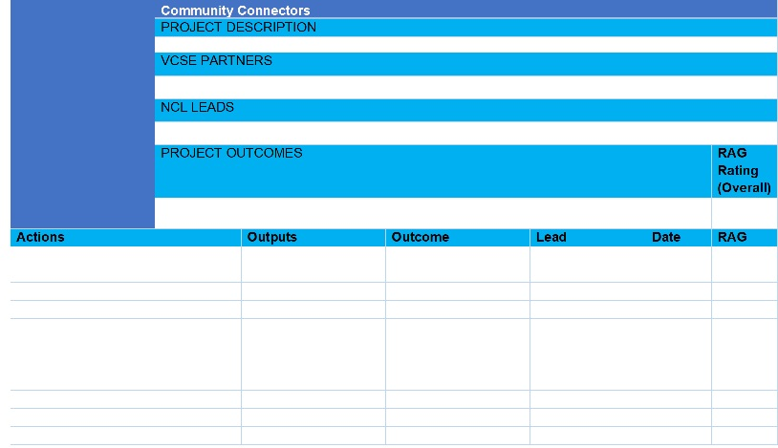

Submitting a proposal

See Appendix 3, Invitation to bid form.

Please complete this form return it to karina.sale@nhs.net by 5pm on Friday 23 August.

Community Connectors with a focus on heart health - North Central London Integrated Care System (nclhealthandcare.org.uk)
Community Action Research - North Central London Integrated Care System (nclhealthandcare.org.uk)
NHS England » Core20PLUS5 (children’s) – an approach to reducing healthcare inequalities

