2024 Staff Survey Report
Dr Rhia Gohel
July 2025

Executive summary
This report provides a high-level overview of the 2024 national Staff Survey results for the ICB.

The initial Staff Survey Results for 2024 compares NCL ICB to other ICB organisation across England and the London ICBs, as well as providing comparison data within the ICB and breakdown by directorate and team (where there has been more than 11 respondents). This year the ICB significantly invested in its Organisational Development and Learning and Development programmes of work, and the data shows good improvements in these areas that were prioritised.

Though headway was made in those key areas, the results are still indicative of an organisation that has been impacted by significant change and the challenge that comes with this, including within ways of working, roles and responsibilities, and within the changing landscape that it operates within.

Figure 1 demonstrates our response rate.

Figure 1: Response rate
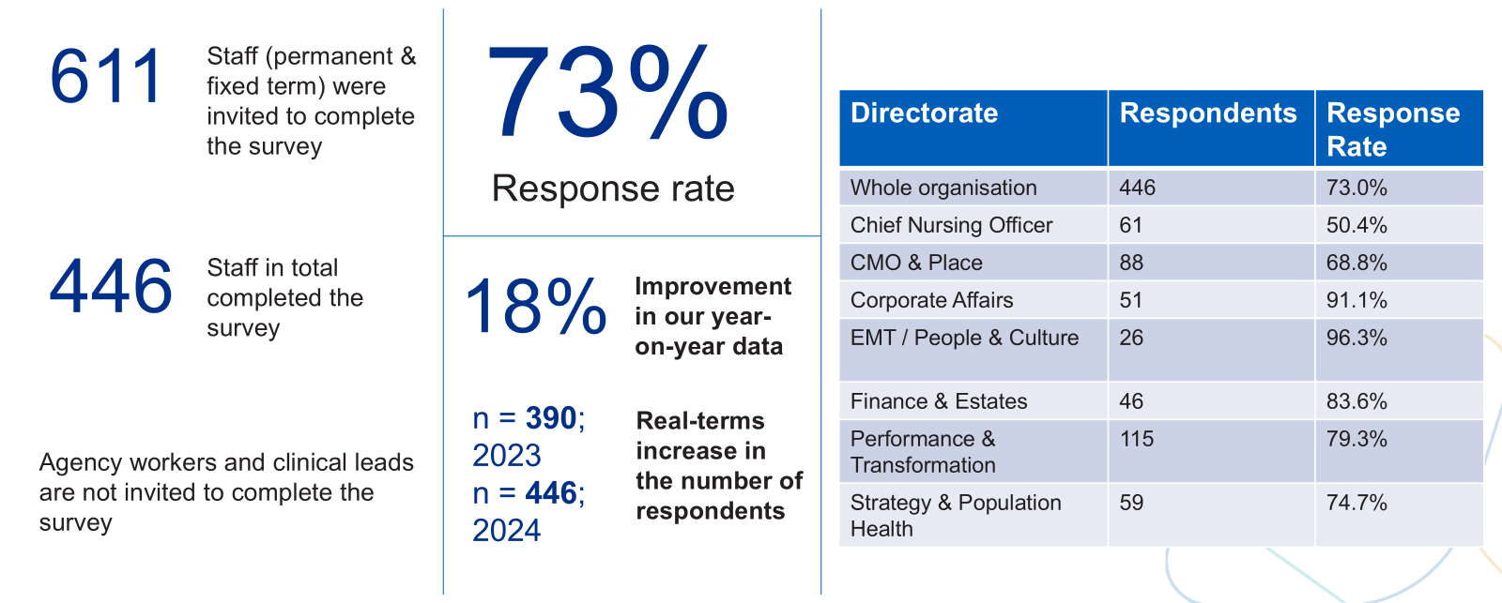

Our completion rate was 73%, which is a significant improvement on our completion rate from 2023. This could be attributed to increased efforts in promoting the Staff Survey across the organisation via our regular comms and engagement channels, including promotion within All Staff and Directorate level briefings, our ‘popcorn to say thanks’ promotion, running specific Staff Survey ‘myth busting’ comms articles and presenting myth busting Q&As in important staff forums (such as within the Joint Partnership Group meetings). It could also be due to directly communicating with our Executive and Director level colleagues on a weekly basis around the most up to date completion rates.

In comparison to other ICB organisations, the ICB’s completion rate compared just below average, with the lowest ICB completion rate reported at 66.4%, the average at 75.9% and the highest at 86.5%.

Key findings:
- Our most positive result is around staff learning and development, including improvements around appraisals and objective setting, staff feeling supported to develop their potential and staff feeling as if they can access the right learning and development opportunities when they need to.
- There were also further improvements in staff not planning on leaving the organisation, which is likely related to staff feeling more settled in their role in comparison to the previous year’s data.
- The ICB also either improved or stayed level on its scoring for all of the People Promise areas, and made significantly greater improvements in the following People Promise areas: We are Recognised and Rewarded, We are Always Learning, Staff Engagement and Morale. This is likely due to there being a greater focus on improving these areas during the 24/25 period.
- However, it is recognised that although the ICB has not declined in any of its People Promise areas, the areas that it has not made significant improvements will need to be focussed on in the 25/26 year.
- It is also important to note that the ICB is performing just below the national average in all People Promise areas, in comparison to other ICB organisations.

To address the above challenges, we have already committed to delivering the objectives of our 2023-2026 OD Plan, through its 6 key pillars of Vision and Values, Goals and Performance, Learning and Innovation, Support, compassion and Wellbeing, Equity and Inclusion and Team and System Working. This has been further enhanced by the development of the HR and OD Team’s 25/26 Business Plan, which also includes addressing the staff survey feedback. A breakdown of how this is being rolled out is detailed within this document.

By committing to the above, it is envisaged that we will continue to make positive strides in improving staff experience and therefore enabling our staff to perform and deliver at their best for the population we serve.

The full NCL ICB 2024 staff survey results are available to review on the NHS Staff Survey website.

People Promise scores

National ICB comparison data

Figure 2 provides a summary by themes against the national ICB average and both best and worst performing ICBs across the country.

All the People Promise elements, themes and sub-scores are scored on a 0-10 scale, where a higher score is more positive than a lower score. These scores are created by scoring questions linked to these areas of experience and grouping these results together.

The ICB is below average against all the themes, this year is the closest that the ICB has scored against the average ICB score for each people promise theme.

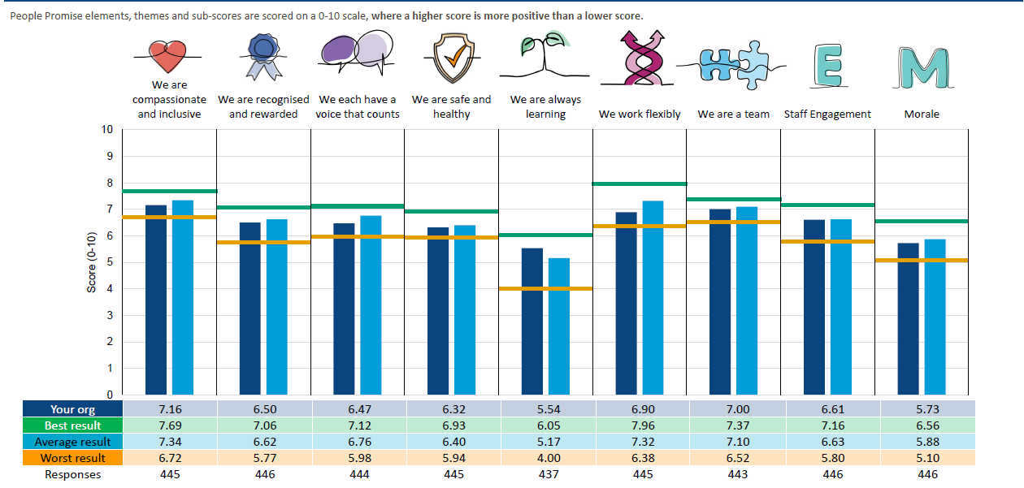
Figure 2: 2024 NCL ICB People Promise Scores compared to other ICB organisation

London ICB comparison data

Figure 3 provides a comparison of the NCL ICB scores in each people promise theme against other London ICBs. NCL ICB scored the second highest in all people promise themes except two (We are always learning, and We are a Team) which scored the highest due to investing and prioritising these two areas during 23/24.

Figure 3: 2024 NCL ICB People Promise Scores compared to London ICB organisations

Organisation | Response Rate | We are Compassionate and Inclusive | We are recognised and rewarded | We each have a voice that counts | We are safe and healthy | We are always learning | We work flexibly | We are a team | Staff Engagement | Morale
ICB Best result | - | 7.69 | 7.06 | 7.12 | 6.93 | 6.05 | 7.96 | 7.37 | 7.16 | 6.56
ICB Average | - | 7.34 | 6.62 | 6.76 | 6.40 | 5.17 | 7.32 | 7.10 | 6.63 | 5.88
SEL ICB | 62% | 7.33 | 6.56 | 6.83 | 6.40 | 5.09 | 7.22 | 6.95 | 6.84 | 5.88
NCL ICB | 73% | 7.16 | 6.50 | 6.47 | 6.32 | 5.54 | 6.90 | 7.00 | 6.61 | 5.73
SWL ICB | 74% | 7.01 | 6.16 | 6.30 | 6.30 | 4.16 | 6.81 | 6.63 | 6.41 | 5.53
NEL ICB | 79% | 6.87 | 6.07 | 6.14 | 6.06 | 4.59 | 6.55 | 6.75 | 6.22 | 5.28
NWL ICB | 65% | 6.74 | 5.94 | 6.13 | 6.01 | 4.17 | 6.38 | 6.58 | 6.23 | 5.28

Top and Bottom 5 areas

Figure 4 summarises the organisation’s Top and Bottom 5 areas.

Figure 4. Top and bottom scores vs organisation average & most improved and declined scores

Top 5 scores vs Organisation Average | Org | Picker Avg | Bottom 5 scores vs Organisation Average | Org | Picker Avg
q23c. Appraisal helped me agree clear objectives for my work | 43% | 35% | q15. Organisation acts fairly: career progression | 40% | 53%
q23a. Received appraisal in the past 12 months | 85% | 80% | q14d. Last experience of harassment/bullying/abuse reported | 37% | 47%
q12c. Never/rarely frustrated by work | 21% | 17% | q6c. Achieve a good balance between work and home life | 58% | 67%
q23b. Appraisal helped me improve how I do my job | 24% | 20% | q19c. Organisation ensure errors/near misses/incidents do not repeat | 56% | 65%
q5c. Relationships at work are unstrained | 57% | 53% | q19b. Encouraged to report errors/near misses/incidents | 71% | 80%
Most improved scores | Org 2024 | Org 2023 | Most declined scores | Org  2024 | Org  2023
q24d. Feel supported to develop my potential | 57% | 40% | q7g. Team deals with disagreements constructively | 56% | 65%
q26a. I don’t often think about leaving this organisation | 41% | 25% | q7d. Team members understand each other's roles | 58% | 63%
q26b. I am unlikely to look for a job at a new organisation in the next 12 months | 39% | 24% | q7h. Feel valued by my team | 68% | 73%
q26c. I am not planning on leaving this organisation | 48% | 33% | q22. I can eat nutritious and affordable food at work | 67% | 72%
q24e. Able to access the right learning and development opportunities when I need to | 48% | 35% | q19c. Organisation ensure errors/near misses/incidents do not repeat | 56% | 60%

The above data indicates that the ICB has made strong progress around its learning and development objectives, including improving the quality and access to appraisals, and staff feeling that they are supported to develop their potential. Staff have also felt that they are more able to access the right learning and development opportunities when they need to. Further improvements are around staff not thinking or planning to leave the organisation.

However, the ICB still has more to do regarding perceived equitable and fair access to career progression opportunities. There is also a clear theme around improving workplace behaviours, including there being an increase in the number of staff experiencing bullying, harassment and discrimination, and the ICB slightly declining on how teams deal with disagreements, how teams understand each other’s roles and whether staff feel valued by their teams. The ICB has also seen a small decline in scores around reporting near misses/incidents and health and wellbeing, specifically staff feeling they are not able to achieve a good balance between their work and home life and not being able to eat nutritious and affordable food at work.

Directorate breakdown
Out of our directorates, EMT and People and Culture is the only directorate that is performing better in all people promise areas than the overall ICB average. The Finance and Estates Directorate are also performing better in most of the people promise areas than the overall ICB average.

Strategy and Population Health, Performance and Transformation, Corporate Affairs and Chief Nursing Officer Directorates are performing near to the overall ICB average in its people promise areas.

CMO and Place however are the only directorate that are performing below average in each of its people promise area, in comparison to the organisation average.

Further analysis of each People Promise area
This section highlights areas within each people promise theme where the ICB has improved and where there has been no real change/decline in comparison to last year’s staff survey results. It also outlines what we have planned to do in the 25/26 year to address some of these challenges.

We are compassionate and inclusive
This year’s data demonstrates that we have made some improvements within this People Promise area, including improvements in staff feeling the organisation places the care of patients/service users as its top priority and the ICB acting on concerns raised by patients.

Overall, there has been an improvement in most of the equality, diversity and inclusion areas. The increase in representation of under-represented groups, greater parity during recruitment processes can be directly linked to our work relating to inclusive recruitment programme which included having fully trained Recruitment Inclusion Advisors (RIAs) on every interview panel, a refreshed training programme for RIAs and managers, and coaching circles for RIAs to share learning, best practice, consistency, fairness and build confidence.

However, bullying, harassment and discrimination and fairer access to career progression opportunities continues to be areas the ICB needs to provide better experiences for staff.

To support positive development in these areas, we will incorporate the areas of improvement into the Equalities, Wellbeing and Careers support plan that will be put in place to support staff during the forthcoming change programme.

We are recognised and rewarded
Staff have indicated that there are greater levels of job satisfaction and level of pay, and that there has been an improvement in them feeling valued by the organisation and their manager. This may be as a result of the pay award that was given to all NHS Staff in the 2024 year, as well as investment in the redesign of our appraisals process which placed an emphasis on key achievements. It may also be due to the enhanced Learning and Development offer that was provided to staff, as the evidence shows that investment in Learning and Development opportunities is usually seen by staff as a positive benefit and recognition of their hard work and commitment. It may also be down to the ICB improving its communications channels and the focus that has been placed on Leadership Development over the last year.

However, staff have felt that the organisation could do better in staff showing appreciation to one another. We incorporated an element of appreciation into the staff away day that took place in May 2025.

We each have a voice that counts
This year’s data shows that more staff know what their work responsibilities are and more involved in deciding changes that affect their team. Staff have also said that they feel more able to make improvements in their area of work. This may be as a result of the investment placed in the High Performing Teams and Leadership Development Programmes. It may also be due to the Senior Leadership and Executive Team continuously discussing the importance of ensuring all voices are heard within high profile and organisational-wide meetings and communications.

However, there has been a decline in staff feeling they are trusted to do their job and in staff feeling involved in suggested improvements to work and deciding changes to their team. There has also been little improvement in staff feeling there is a choice in how work is undertaken. This may be due to standing up a new organisational structure, the transition arrangements to the new structure which involved filling vacant posts and establishing new ways of working. To address some of these areas, each directorate has contributed to the 25/26 business planning process which involves setting clear objectives and work plans to account for staff capacity and capability.

We are safe and healthy
There has been an improvement in staff feeling that the organisation takes positive action on health and wellbeing, with a slight increase in staff feeling that there are adequate materials and equipment to do their roles, and enough staff to do their job. There has also been a slight improvement in staff feeling unwell due to work related stress and a slight overall reduction of experiencing bullying and harassment from colleagues. Other areas of improvement include decline in staff feeling work is emotionally exhausting, staff feeling burnt out, and a decline in staff finding work frustrating. This could be as a result of putting in place support following the enhanced Wellbeing Temperature Check Survey that was carried out, as well as vacant posts being gradually filled over time, and providing greater management and leadership development for managers to take a more compassionate and inclusive way of supporting staff.

However, there has been a slight decline in staff being able to meet conflicting demands, having unrealistic time pressures and reporting experiences of bullying and harassment. There has also been a slight increase in staff experiencing MSK issues. There has also been a very small increase in the number of staff coming into work when they are not feeling well and a slight increase of physical violence from managers/colleagues.
There has been a slight increase in staff reporting greater bullying and harassment from managers and a slight increase in staff experiencing unwanted behaviour of a sexual nature from staff, colleagues and patients, service users, their relatives or members of the public. There has been a decline in staff eating nutritious and affordable food whilst working.

To address the areas outlined above, we have established a Wellbeing Group with representatives from across the ICB. The group is responsible for reviewing and developing wellbeing programmes to improve staff wellbeing over the next year, particularly during the change programme. As part of our support offer to staff and managers during the change programme, we have committed to providing wellbeing workshops for staff and managers, MSK support and supporting staff with dealing with uncertainty.

We are always learning
There have been significant improvements in staff feeling the organisation offers challenging work and opportunities to develop their career and their skills and knowledge. Staff have also reported that they feel supported to develop their potential and that they are able to access the right learning and development opportunities, with an improvement also being made in the number of staff reporting they have had an appraisal.

Success in this area has largely been down to the significant investment into our Learning and Development programme this year, including, the enhanced learning and development offer, our commitment to ensuring staff could access additional learning and development opportunities, funding, apprenticeships levy and the redesign of our appraisals process, incorporating career aspirations and wellbeing. We will continue to provide access to learning and development opportunities over the forthcoming year.

We work flexibly
There has been an increase in staff feeling that the ICB is committed to helping them to balance work and home life and being able to approach their immediate manager to talk openly about flexible working. There has been a slight decline in staff being satisfied with key aspects of their job and opportunities for flexible working patterns and achieving a good work-life balance.
We recognise that more work needs to be done in this area and so over the next year, there will be a greater commitment to updating and revising the suite of flexible working/family friendly policies and continuing to support hybrid working arrangements.

We are a team
There has been an improvement in teams feeling they hold shared objectives and working better together to achieve these. There have also been improvements in managers providing encouragement and feedback. However, there has been a slight decline in staff feeling that they get the respect they deserve from other colleagues, managers taking a positive interest in health and wellbeing, understanding each other’s roles. These areas may have declined due to standing up the new structure, line manager changes, and transitioning to the new structure and ways of working during 2024.

The continuation of the leadership and management development programmes and managers training to support staff through change during the forthcoming change programme may strengthen the areas that require improvement. It is also envisaged that the staff away day held in May provided an opportunity to further foster a sense of team belonging across the organisation.

Engagement
There have been improvements in the following areas:
- Motivation
- Involvement
- Advocacy
- Look forward to going to work
- Enthusiastic about my job
- Time passes quickly when working
- Making improvements in own area of work
- Care of patients is org top priority
- Recommend org. as place to work

However, staff have reported that the ICB could do better in providing opportunities to show initiative and making suggestions to improve the work of the team.

Morale
There have been improvements in the following areas:

- Thinking about leaving
- Looking for a job in next 12 months
- Adequate materials, supplies
- Enough staff to do job properly
- Know work responsibilities
- Involved in deciding changes that affect work
- Encouragement from manager
However, there has been no change/a decline in the number of staff reporting the following:
- Able to meet conflicting demands
- Unrealistic time pressures
- Choice how to do job
- Strained relationships at work
- Respect from colleagues

WRES/WDES
The below sections outline the organisation’s performance for WRES and WDES scores, taken from this year’s Staff Survey data.

Workforce Race Equality Standard (WRES)
The WRES data shows a slight improvement in White and BME staff experiences of bullying, harassment and abuse from patients, services or their relatives. Whilst white staff have had a slight improvement in experiences of bullying, harassment and discrimination, BME staff have reported worsened experiences.

There has also been a decline in the number of BME staff believing that the organisation provides equal opportunities for career progression or promotion, however this has improved for White staff.

Figure 5: WRES 2024 Staff Survey Data

WRES Indicator | 2023 data |  | 2024 data | Comparison for BME staff
Percentage of staff personally experiencing harassment, bullying or abuse at work from…Patients / service users, their relatives or other members of the public in the last 12 months |  | BME staff: 5.34%  White staff: 7.59% | BME staff: 4.98%  White staff: 6.93% |  | Improvement
Percentage of staff experiencing harassment, bullying or abuse from staff in last 12 months |  | BME staff: 23.85%  White staff: 19.41% | BME staff: 26.87%  White staff: 18.18% |  | Decline
Percentage of staff feeling the organisation provides equal opportunities for career progression or promotion |  | BME staff: 32.3%  White staff: 41.1% | BME staff: 31.19%  White staff: 49.57% |  | Decline
Percentage of staff experiencing discrimination from staff in the last 12 months |  | BME staff: 14.9%  White staff: 11.1% | BME staff: 18.09%  White staff: 9.61% |  | Decline

Workforce Disability Equality Standard (WDES)

Our performance against the WDES indicators shows the following changes in performance in comparison to 2023 results:

- The percentage of disabled staff compared to non-disabled staff believing the ICB provides equal opportunities for career progression or promotion has increased from 32.4% in 2023 to 39.4% in 2024.
- An increase in the percentage of disabled staff compared to non-disabled staff saying that the last time they experienced harassment, bullying or abuse at work, they or a colleague reported it
- The percentage of disabled staff compared to non-disabled staff saying that they have felt pressure from their manager to come to work, despite not feeling well enough to perform their duties has reduced from 25.8% in 2023 to 17.6% in 2024.
- The percentage of disabled staff compared to non-disabled staff saying that they are satisfied with the extent to which their organisation values their work has increased from 32.1% in 2023 to 45.7% in 2024.
- The percentage of disabled staff saying that their employer has made reasonable adjustment(s) to enable them to carry out their work has increased from 70.7% to 75.7% in 2024.
- An increase in the percentage of disabled staff compared to non-disabled staff saying that they are satisfied with the extent to which their organisation values their work

The areas that have declined include the percentage of staff with a disability, illness or long-term condition experiencing harassment, bullying or abuse from patients, managers or colleagues which has increased from 2023.

Figure 6: WDES 2023 Staff Survey Data

WDES Indicator |  | 23/24 data | 24/25 data | Comparison for staff with a LTC/ disability
4a | Percentage of disabled staff compared to non-disabled staff experiencing harassment, bullying or abuse from patients, service users or public | With LTC or illness: 6.73%  No LTC or illness: 6.91% | With LTC or illness: 7.14%  No LTC or illness: 6.17% | Decline
4b | Percentage of disabled staff compared to non-disabled staff experiencing harassment, bullying or abuse from managers | With LTC or illness: 18.45%  No LTC or illness: 10.95% | With LTC or illness: 20.63%  No LTC or illness: 11.44% | Decline
4c | Percentage of disabled staff compared to non-disabled staff experiencing harassment, bullying or abuse from other colleagues | With LTC or illness: 24.04%  No LTC or illness: 13.14% | With LTC or illness: 27.20%  No LTC or illness: 8.44% | Decline
4d | Percentage of disabled staff compared to non-disabled staff saying that the last time they experienced harassment, bullying or abuse at work, they or a colleague reported it | With LTC or illness: 40.63%  No LTC or illness: 40.38% | With LTC or illness: 46.67%  No LTC or illness: 31.48%% | Improvement
5 | Percentage of disabled staff compared to non-disabled staff believing that their organisation provides equal opportunities for career progression or promotion | With LTC or illness: 32.38%  No LTC or illness: 37.68% | With LTC or illness: 39.37%  No LTC or illness: 41.37% | Improvement
6 | Percentage of disabled staff compared to non-disabled staff saying that they have felt pressure from their manager to come to work, despite not feeling well enough to perform their duties | With LTC or illness: 25.76%  No LTC or illness: 12.03% | With LTC or illness: 17.58%  No LTC or illness: 15.94% | Improvement
7 | Percentage of disabled staff compared to non-disabled staff saying that they are satisfied with the extent to which their organisation values their work | With LTC or illness: 32.08%  No LTC or illness: 45.85% | With LTC or illness: 45.67%  No LTC or illness: 51.63% | Improvement
8 | Percentage of disabled staff saying that their employer has made reasonable adjustment(s) to enable them to carry out their work* | With LTC or illness: 70.69%  No LTC or illness: n/a | With LTC or illness: 75.68%  No LTC or illness: n/a | Improvement
9 | Staff Engagement Score | With LTC or illness: 5.5  No LTC or illness: 6.5 | With LTC or illness: 6.3  No LTC or illness: 6.8 | Improvement

*No comparable data from previous year

Our OD Plan: Actions taken to date
The design of our organisational change programme contained 3 key strands: Organisational Design, Ways of Working and Organisational Development. As part of this, the 2023-26 OD Plan was launched in July 2023 which aimed to identify how the organisation would be reformed, taking into account the key pillars that would support this. The 6 key pillars identified are: Vision and Values, Goals and Performance, Learning and Innovation, Support, Compassion and Wellbeing, Equity and Inclusion and Team and System Working. The following summary outlines the key programmes of work that have also been aligned to staff survey results:

- Established a new OD Team to support the development of our culture. The OD Team works alongside our leaders to support them in creating a safer, healthier and more inclusive environment where staff can thrive.
- Established a programme to automate processes in HR, finance and other areas of the organisation to streamline our processes and improve the working experience for staff
- Recognised that the building blocks of our organisation are our teams, and the success of our teams results in the success of our organisational vision and objectives, including being able to deliver our key objective of reducing health inequalities and improving patient care. To enable this, the organisation invested in a High Performing Teams programme. To date, this has enabled all teams within the new organisational structure to identify new ways of working and support the development of a new local culture to achieve our organisational objectives. Phase 1 of the programme completed in July 2024, with all teams across the ICB completing the programme.
- Launched a Leadership Development Programme in 2024 for our Senior Leadership. This year long programme concluded in April 2025 and has supported our senior team to aims to navigate leadership challenges in an environment that requires cultural change, to facilitate innovative systems leadership and thinking.
- Redesigned and launched our Core Skills for Managers programme, aimed at our middle managers, to enable them to understand the fundamentals of leadership in a climate that requires innovation, sensitivity and critical thinking to build teams that feel empowered and capable to tackle the current and future challenges faced in trying to address health inequality.
- Designed a Leadership framework which provides an aspirational foundation and aims to support all leaders from across the organisation to invest in themselves and be the best leaders they can be. All leadership development programmes have been designed and developed in accordance with the framework, to ensure that our leaders all have the same set of standards to adhere and aspire to.
- Inclusive Recruitment Programme to actively demonstrate a commitment to Diversity and Inclusion. This included the design of an Inclusive Recruitment training programme for recruitment managers as well as the introduction of the Recruitment Inclusion Advisor role, that sits on every interview panel.
- A complete overhaul of our Learning and Development offer for staff, including the appointment of the Learning and Development Manager, the facilitation of an annual Training Needs Analysis to better understand the learning and development needs of the organisation, and the establishment of a core Learning and Development offer for staff. The OD team has also redesigned and launched its onboarding and induction programme, including local induction for new starters. We have also made vast improvements to ensure that our Statutory and Mandatory training is reaching high compliance rates. The OD team has also launched a highly popular additional funding offer for staff to access additional learning and development opportunities to support career progression. To support this, the OD team has also refreshed its Learning and Development Policy and its Professional Registration and Revalidation Policy.
- Developed our wellbeing offer, including facilitating a Health and Wellbeing Survey, establishing a Wellbeing Group, launching the Shiny Minds App, and access to our Occupational Health and Employee Assistance Programme service.
- Facilitated an annual all staff away day to bring all teams together.
- Launched a formalised approach to supervision for our staff in roles with high level of emotional burden, to enable them to feel supported.
- Developed a quarterly workforce performance report to support the collation and analysis of the triangulation of our staff data to identify trends, areas going well, areas that require improvement to develop the right interventions.
- Signed up to the National Sexual Safety Charter and developed an action plan to meet the Charter’s requirements, including delivering training to line managers and staff
- Invested in the Shiny Mind app to better support staff mental health and wellbeing

Conclusion and next steps

The areas that have been identified in the staff survey that require improvement will be addressed via the equality, wellbeing and careers support plan that has been rolled out to support staff during the forthcoming change programme. The plan also includes the continuation of some of the workforce programmes that have enabled the ICB to improve significantly over the past year, for example access to learning and development opportunities, inclusive recruitment programme, management and leadership development and wellbeing. Directorates will also continue to address Directorate specific gaps and will be monitored via the quarterly assurance meetings with the Chief Executive Officer, Chief Finance Officer and Chief People Officer.

Due to the forthcoming change programme, a decision has been taken to pause the requirements of delivering the OD plan and focus on supporting staff throughout the change programme with regards to wellbeing, careers support and fair and inclusive processes.

