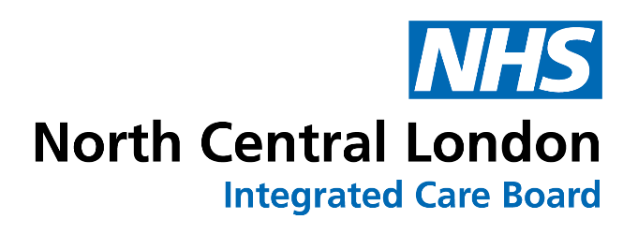

Primary care rebate schemes
Primary care rebate schemes (PCRS) are contractual arrangements offered by pharmaceutical companies, or third-party companies, which offer retrospective financial rebates to the ICB on GP prescribing expenditure for particular branded medicine(s). The availability of a scheme does not influence the inclusion of specific medicines in care pathways or formularies. Healthcare professionals will continue to base their prescribing decisions on individual assessments of their patients’ clinical circumstances. The decision to initiate treatment or change a patient’s treatment regime should always be based on up-to-date best clinical evidence or guidance, for example, from the National Institute for Health and Clinical Excellence (‘NICE’), or other approved authoritative sources.

NCL ICB policy governing primary care rebate schemes can be accessed here.

North Central London ICB has signed up for the following primary care rebate schemes:
Rebate (Brand) | Generic name  (if applicable) | Therapeutic area | Start date | End date | Company
Clenil® Modulite® Inhaler | Beclometasone dipropionate | Respiratory | 01 April 2024 | 31 March 2026 | Chiesi Limited
FreeStyle®  Libre ® | N/A | Endocrinology | 01 July 2025 | 30 June 2026 | Abbott Laboratories Limited
Fostair® NEXThaler® | Beclometasone dipropionate with formoterol fumarate dihydrate | Respiratory | 01 October 2023 | 30 September 2025 | Chiesi Limited
Fostair® pMDI | Beclometasone dipropionate with formoterol fumarate dihydrate | Respiratory | 01 April 2024 | 31 March 2026 | Chiesi Limited
Prostap® | Leuprorelin | Endocrinology / Oncology | * | * | Takeda UK Limited
Slenyto® | Melatonin | Neurology | 01 July 2023 | 30 June 2026 | Flynn Pharma Ltd
Monopost® | Latanoprost | Ophthalmology | 01 August 2025 | 31 July 2027 | Théa Pharma Limited
*This is classified as “supplier confidential information”.



